Dear Client,

Special occasions, big meetings, celebrations – at Hampton Inn & Suites – Tyler/South, we know how important they are, and we know how to make them rewarding and memorable.

Please take a moment to look over the meeting options. You’ll find plenty of choices, complemented by our knowledgeable and attentive team, professionals who are committed to creating a successful event for you and your guests. If you have any questions, please do not hesitate to contact us.

Thanks for making us a part of your plans. Once again, welcome to the Hampton Inn & Suites – Tyler-South!

With Greatest Gratitude,

Staff & Management
Hampton Inn & Suites Tyler-South

Hampton Inn & Suites – Tyler-South
8962 S. Broadway Avenue
Tyler, Texas 75703
(903) 630-7272 / Fax: (903) 630-7277
Meeting Options

General Information

GUARANTEES
To ensure precise setup in your meeting space, a final guarantee is required three business days prior to the event.
Note: each catering company may require a stricter time line and will be discussed at time of signing Banquet Event Orders.

Any meeting or special event that is canceled that cannot be rescheduled that is also outside of grace period, which is determined at the time of signing Agreement, will be assessed with an cancellation fee according to attrition schedule.
Note: each catering company may hold different cancelation policies separate from hotel.

FORCE MAJEURE
If an event is canceled due to extraneous environmental, political, religious, revolutionary, terrorism, or other circumstances and cannot be rescheduled, no attrition will be assessed.

SERVICE OPTIONS
All meeting options will be assessed with a eighteen percent, non-taxable service charge which covers set-up, cleaning and break-down of each event.

SETUP OPTIONS
Our team will do everything possible to accommodate most setups; however if a setup is agreed upon and extensively changed within 24-hours of the event a re-setting fee may be applied beyond twenty percent service fee.
Room Setup Options

Dining Styles
Banquet Rounds
Rounds of 8: 80 Max
Rounds of 6: 60 Max

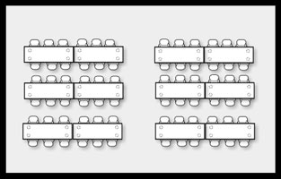
Traditional Banquet
Rectangle of 8: 72 Max
Rectangle of 6: 54 Max

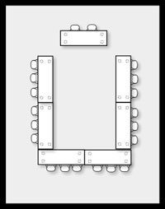
U-Shape
With Head Table: 38 Max
Without Head Table: 36 Max

Closed Square
2 tables x 3 tables: 46 Max
1 table x 3 table: 28 Max

Meeting Styles
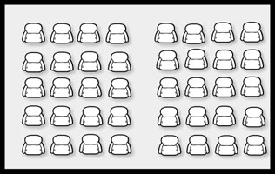
Theatre
80 Max

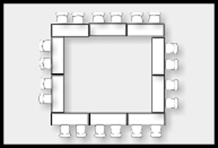
Open Square
3 per-table: 27
2 per-table: 18

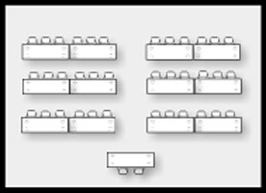
Classroom
36 Max

If your event needs a different layout than what is listed, please visit with our team so that we can attempt to accommodate your setup.

Hampton Inn & Suites – Tyler South Catering Menu

Breakfast

On The Light Side

Choice of Apple or Orange Juice
Breakfast Muffins or Pastries
Fresh Cut Fruit
$7.95 per Person++

The Good ole Boy

Choice of Apple Juice or Orange Juice
Fresh Cut Fruit
Breakfast Potatoes
Bacon or Sausage
Scrambled Eggs
$13.95 per Person++

AM Breaks

The Fruit-bowl – $3.95 per Person++
Fresh Whole Fruit

Nom Nom Granola - $4.95 per Person++
Healthy Premium Granola Bars

Kids Again - $5.95 per Person++
Classic, Nostalgic “Kid” Snacks
A mix of graham crackers/peanut butter crackers, raisins

Coffee: $22.00 per gallon++
Hot Tea: $18.00 per gallon++
Lemonade: $22.00 per gallon++

The Lumberjack

Choice of Apple or Orange Juice
Pancakes
Fresh Cut Fruit
Bacon or Sausage
$9.95 per Person ++

PM Breaks

Sugar Monster – $12.95 per Dozen++
Fresh Baked Cookies or brownies

Yin & Yang - $6.95 per Person++
Baked or Original Chips & Candy Bars

You Gotta Be Nuts! - $6.95 per Person++
A Mix of Nuts and Berries

Popcorn Bar - $4.95 per Person++
A Mix of flavored popcorn

Assorted Soft Drink: $2.50 each++
Bottle Water: $2.00 each++
Ice Tea: $18.00 per gallon++

We can customize AM/PM breaks according to your need. Prices will vary.
++ All prices are subject to 8.25% sales tax and 18% service charge
AUDIO VISUAL

Overhead Projector / Screen: $75.00 per day++
Screen Only: $25.00 per day++
Flip Chart/Markers: $25.00 per day++
Lap Top: $150.00 per day++
Cordless Microphone: $50.00 each, per day++
Photo Copies: .20 per copy (first 10 copies is complimentary)

LINEN RENTAL

We have Nine 6ft table linens: $5.00 each, per day++
We have Eight 72in round table linens: $7.00 each, per day++

COMPLIMENTARY WITH MEETING/BANQUET ROOM

Water station
1 Pad/Pen per seat (if needed)
Ice (if needed)
Tables / Chairs

++ All prices are subject to 8.25% sales tax and 18% service charge

