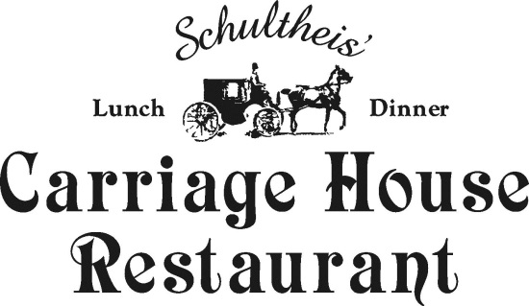

Choose: Three Entrees
Tuesday through Saturday Minimum 30 Guests
38 pp
Day wedding (11am – 4 pm)

Salad Station:
Caesar Salad or Mixed greens
with your choice of dressings
Match Your Favorite Pasta with Our Chef's Finest Sauces
Penne  Tortellini  Farfalle (Bowties) | Tomato, basil cream  Marinara Sauce  Spinach , garlic, olive oil
Fish
Tilapia  Pan Seared Salmon  Haddock | Lemon buerre blanc  Dill Sauce  Herb Crusted
Meat
Pork Medallions Normandy
*Chicken Marsala or Chicken Picante or Chicken Parmesan
Huhner Schnitzel
Filet tips Burgundy/ Egg Noodles
Sliced Top Round of Beef Au Jus and Horseradish Sauce
Choose One Starch and One Vegetable
Roasted Red Bliss Potatoes  Home-made Mashed potatoes  Potatoes Au Gratin  Twice baked Potatoes | Fresh String Beans Almandine  Sautéed Zucchini, onion and Carrots  Green Peas With Pearl Onions  Fresh Broccoli

Desserts
Wedding Cake!
Includes Coffee and Tea, Iced Tea
Includes Salad, Vegetable, Potato and Fresh Bread and dessert selection

*Add a Cup of Soup or A Fresh Assorted Cheese and Artisan Cracker display
*Pricing does not include gratuity and sales tax on Food

