Swan Lake Ceremony Package
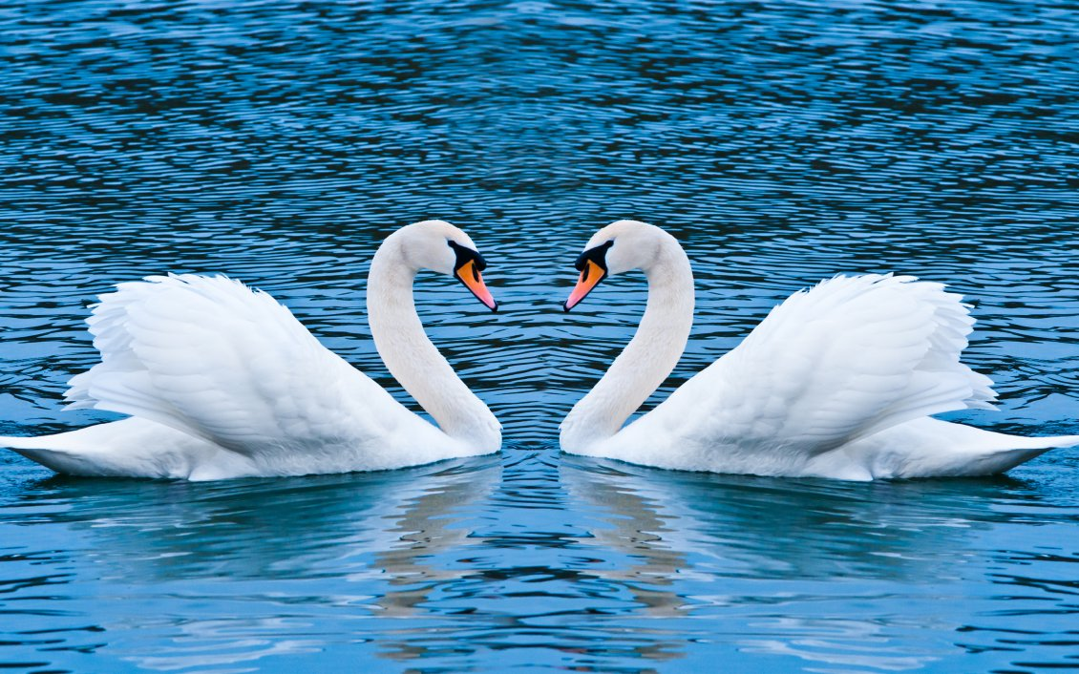

Overlooking our calming and tranquil lake, Snow White Love Swans, babbling waterfall, picturesque mountains and beautiful foliage for your wedding ceremony.

Accommodating Ceremonies for up to 100 guests

The ceremony package includes padded white folding chairs, white wedding trellis and unity table clothed with white floor length linen, assistance of a banquet manager to oversee the ceremony.
$700.00
Plus 22% service charge & 6% tax

Weather back up & room blocking is provided at time of booking your wedding with us. We require a 24 hour notice prior to your wedding date whether to set up your ceremony indoors or out doors.

If a change for the original ceremony location or set up is requested within 24 hours of the function, a change fee of $2.50 per guest will be charged.

Sashes and overlays are available at $2.00 per chair plus 22% service charge & 6% tax

