South Plaza .. ……..…… ……… ……………………………….$quoted
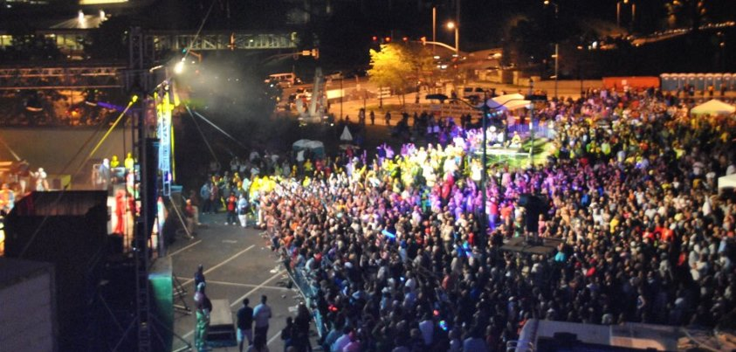 Concerts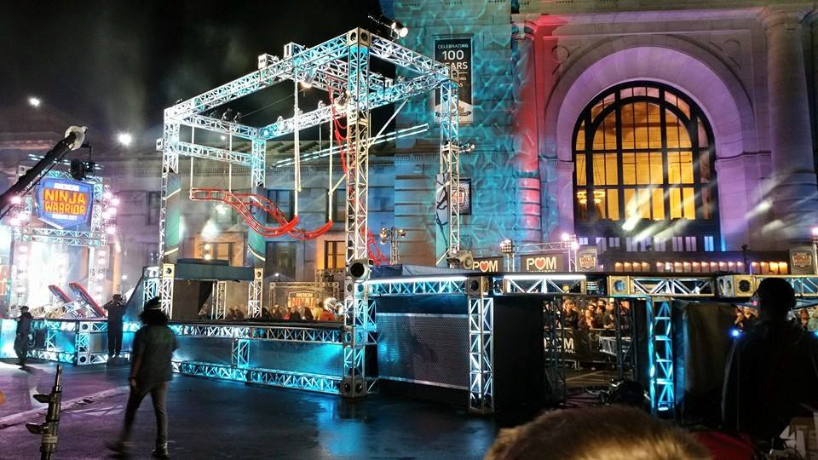 Obstacle Course
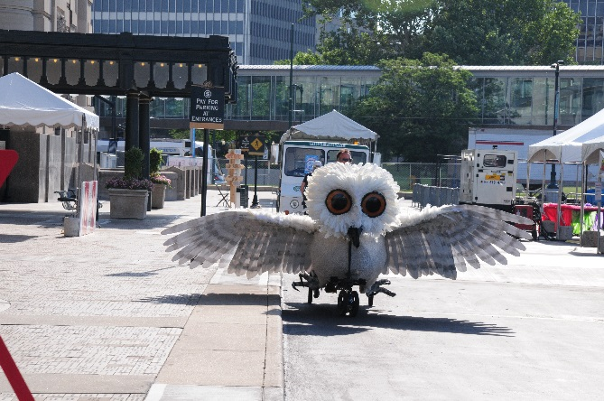 Festivals

Capacity: 8,000 (East and West)

Furniture:
None included. All needs quoted upon request on a per event basis.

Audio/Visual:
Quoted upon request.

Other Amenities:
Henry Bloch Fountain & Liberty Memorial View
Historic Union Station front entrance and arched windows as backdrop.
Perfect outside concert location.

Other Considerations:
Parking/traffic flow
Sprinkler System
Tents are not allowed to be staked into concrete, paving or grassy areas. All tents must be weighted tents.
Fencing (Union Station owns and is the exclusive rental provider of this equipment)
Banner Displays
Lighting in front of building
Staging
Electrical / Generators
Custodial/ Clean Up
KCPD

