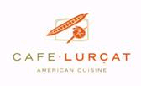

Thank you for considering Café and Bar Lurcat for your upcoming event. We know there are numerous options available to you, so it is an honor just to be considered.
Here at Cafe Lurcat, we have several options for large private parties. With few exceptions, our large parties take place on the upper level of the restaurant.

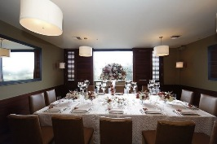

Our Lakeview Dining Room can accommodate up to 36 people comfortably for a sit down dinner, and many more for a small cocktail affair.
For larger groups we offer space in our Main Dining Room, this space can be booked to be private if desired, and is typically used for groups of 60 or more.
Our entire space (Main Dining & Lake View Room) will hold up to 125 people. Due to inconsistent weather, our balcony will generally not be available solely, but can be used as part of your group event for an additional charge.

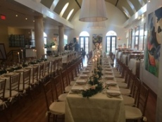

For parties over 16 guests, we will create a personalized menu based on your choices from Chef's Large Party Selections or favorites from our regular menu. We will also provide a list of appetizers available to begin your experience. These can be served plated or passed during cocktail hour.

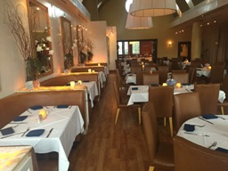

Courses can be served plated individually or buffet style, whichever suits your event. Individual plated service may seem more formal, but buffets can give your guests greater opportunities to try a number of different items on one plate.

Bar bills can be split up a number of ways. We can have an open bar, limited open bar, or cash bar. We recommend preselecting wines to be passed and/or served with dinner. We will gladly provide our Wine List for your reference.

Room set up:
Our Main Dining Room is one large area that can conform to just about any arrangement you desire. It is rectangle in shape, boasts over 2000sqft of open floor space and even has its own personal bar. We have hosted events with one long table, multiple small tables, a dance floor, cocktail area, even a lounge and photo booth!

We offer restrooms on the second floor as well as an elevator for ease of access and comfort during your event.

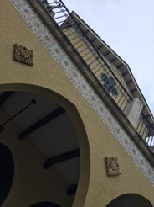

Parking:
At this time, we do not have a parking lot to offer for your guests nor do we have a valet service. There is ample street parking along 5th Ave, the surrounding streets, as well as many smaller service lots and a parking garage nearby. These are all free of charge.

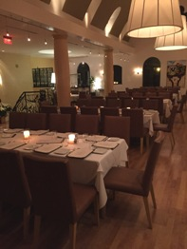

Payment:
For corporate events, we will sign any contracts required on your end only once payment method, guest count, maximums, and menu's are settled.
Room deposits are not required, but gladly accepted to hold your space for the night desired. We typically finalize the menu two weeks prior to the event.
Our spaces are generally booked on minimums in sales, which include all food and beverage from the event. The minimums will fluctuate greatly depending on the season and day or week.
Please note 20% service gratuity, 2% event planning gratuity, and 6% sales tax is added in addition to the agreed upon menu price. All gratuities are always added pre-tax.
Please feel free to contact us personally with any questions or concerns you may have. If you’d like to get a personal tour, we will be more than happy to set up a time to meet!

We look forward to your next celebration with us -

Cheers!

Your Cafe Lurcat Team

Cafe & Bar Lurcat

494 5th Avenue South

Naples, FL 34102

239-513-3357

www.cafelurcat.com
@CafeBarLurcatFL

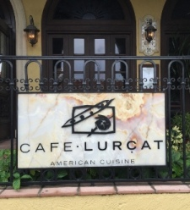

Jesse Miller, General Manager
Brian Urso, Asst. General Manager
Michael Mueller, Executive Chef
Taylor Young, Event Coordinator

Café and Bar Lurcat Event Menus

$55/person
Includes Fresh Bread & Butter Service,
Select Two Accompaniments

Course One - Salad (Select One)
- Granny Smith Apple, Manchego Cheese, and Chive
- Bacon, Lettuce, Tomato - Buttermilk Blue Cheese

Course Two - Entree (Select Two)
- Pot Roast - red wine sauce, thyme, rustic veg
- Seared Yellowtail Snapper - lemon-parsley butter
- Shrimp Risotto - local tomato & parmesan
- Waymore Farms Chicken* - natural jus, seasonal veg
- Scottish Salmon - Korean chili, ginger, forbidden rice
- Creekstone Filet - (add $10)

Course Three - Dessert (Select One)
- Signature Cinnamon & Sugar Doughnuts
- Warm Brownie, Chocolate Cremeux, Salted-Caramel Gelato

$75/person
Includes Fresh Bread & Butter Service,
Select Three Accompaniments

Course One - Salad (Select Two)
- Granny Smith Apple, Manchego Cheese, and Chive
- Bacon, Lettuce, Tomato - Buttermilk Blue Cheese
- Seasonal Selection*

Course Two - Entree (Select Three)
- Creekstone Filet*- truffle béarnaise, grilled asparagus
- Sea Bass - sweet white miso, spicy cucumber slaw
- Seared Yellowtail Snapper - lemon-parsley butter
- Scottish Salmon - Korean chili, ginger, forbidden rice
- Waymore Farms Chicken*– natural jus, seasonal veg
- New York Strip - gascogne butter - (add $10)

Course Three - Dessert (Select Two)
- Signature Cinnamon & Sugar Doughnuts
- Warm Brownie, Chocolate Cremeux, Salted-Caramel Gelato
- Seasonal Selection*

*Please ask event planner about seasonal preparation on these dishes!

Cafe Lurcat
Hors d'Oeuvres
(May be Passed or Plated)
Served by the Piece, prices vary

Seafood
Mini Crab Cake
Tuna Tartare on Crostini
Fresh Atlantic or Pacific Oyster
Miso Sea Bass Spoon

Meats
Lurcat Sliders - Red Wine Butter
Wagyu Philly Cheese Steak - Whiz
Smoked Brisket Tacos - Miso Slaw
Chicken Satay
Beef Satay

Vegetarian
Mushroom Tartlettes - Walnut Crema
Tomato-Basil Tartlettes - Parmesan
Wisconsin Cheddar Gougere

For Groups 2-4:
Grande Seafood Platter – Feeds up to 8
(Seasonal Crab, Cocktail Shrimp, Tuna
Tartare, Fresh Oysters)
Crudité: Veggie, Meat, and/or Cheese
Signature Calamari - Chile Lime
Lurcat Crab Cake (Lg) - Mustard Sauce

Entree Accompaniments
- House-Made Fries
- Potato Puree
- Roasted Cauliflower
- Seasonal Vegetable
  - Varies seasonally between Asparagus & Brussels Sprouts

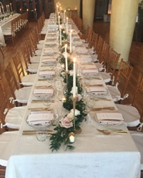

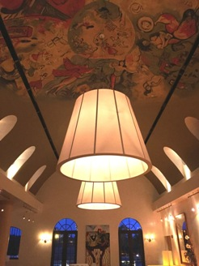

Cafe & Bar Lurcat

494 5th Avenue South

Naples, FL 34102

239-513-3357

www.cafelurcat.com

@CafeBarLurcatFL

Group

Event

Menu's

