1001 W President George Bush Hwy
Richardson, Tx 75080
(972) 792-9393

“Diamond’s”
Wedding Package

♥Complimentary Luxury King Suite for Bride and Groom♥
♥Breakfast for Two ♥
♥White Spandex Chair Covers/Sashes ♥
♥White Floor Length Tablecloths ♥
♥Champagne Rosette Overlays ♥
♥Complimentary Cake Cutting ♥
♥15x15 Dance Floor♥
♥Personalized Mini Chocolate Bars♥
♥Centerpieces with Tea Lights ♥
♥Tile Mirrors♥
$3,500.00 F&B Minimum
$600.00 Setup Fee/Deposit Includes All The Above (Non-Refundable)

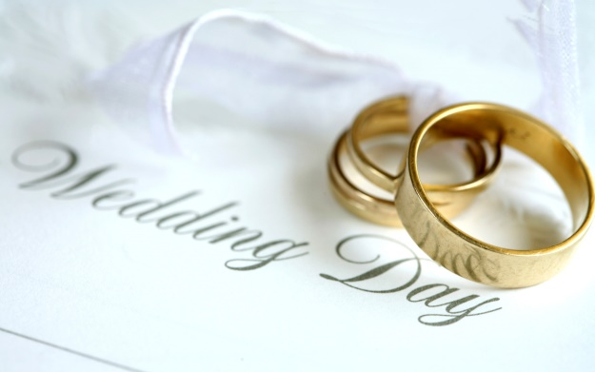

A 22% Service Charge and 8.25% Sales Tax Will Be Added To Minimum

