Holiday Inn & Suites
Phoenix Airport

We welcome the opportunity to help create the most memorable event. Our distinct touches and expertise will allow you to relax and make your day the best as it should be.
Let us take care of you on your most special occasion!

3220 South 48th Street Phoenix, Arizona 85040
Phone (480) 543-1700 Fax (480) 543-1701

Executive Meeting Planner Package:
$55.00++ per person

Continental Breakfast:
Assorted fruit juice, low fat milk, premium roasted regular & decaf coffee
Bagels and cream cheese, fresh baked muffins and Danish
Fresh fruit, cottage cheese and yogurt
Choice of: Breakfast Burrito or Scrambled Eggs and Bacon
____________________________________________________________

Lunch: (Served or Buffet) of your choice for 1 hour of service
See Plated and Buffet menus for selection
____________________________________________________________
PM Break: (Choose One Break)

Healthy Options:
V-Fusion
Assorted fruit juice
Low fat bottled milk
Pop chips
Tropical fruit cup

The Fruit & Veggie:
Assorted soda
Bottled water
Assorted dried fruit
Tropical fruit cup
Crudités of vegetables
with herbed dip
The Sweet & Salty:
Bottled water
Premium roasted regular and decaf coffee
Homemade assorted baked cookies
Mixed nuts and pretzels
Chocolate dipped strawberries
____________________________________________________________
Standard Audio Visual Included:
Podium and microphone
Flipchart with pads and markers
8 ft. screen
High-speed wireless internet
Power strip and extension cord
Logo pads and pens at each place setting
Farewell Cocktail Reception
$24.95++ per person
Two hour service following your meeting

Complete your event with a special reception:

Hors D’oeuvres buffet of 2 hot and 3 cold selections of your choice

Hosted Imported & Domestic bottled beer, house wine,
bottled water, assorted soda and juice

Complimentary use of ballroom space or patio area
with private serving staff and bartender

Cocktail seating and linens with decorative centerpieces

Podium and microphone for announcements and recognition

Standard audio visual included

A La Carte Breaks
All pricings are based per person

Continental Breakfast:
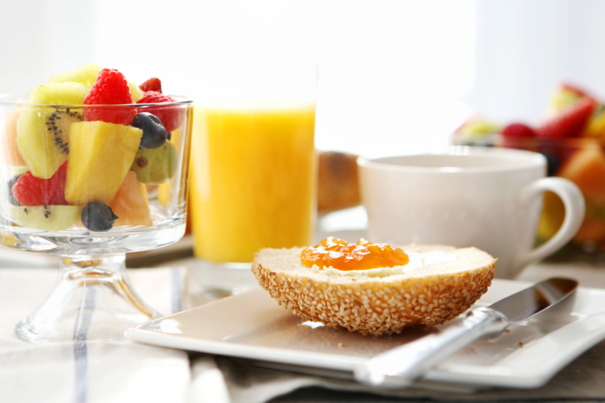
Assorted fruit juice
Low fat milk
Premium roasted regular
and decaf coffee
Bagels and cream cheese
Fresh baked muffins
Danish
Hardboiled egg
Assorted cereal
| $9.95++
_______________________________________________________

AM Break:
Assorted yogurt
Sliced fresh fruit tray with seasonal berries
Natural granola
Cottage cheese
| $5.95++
_______________________________________________________

PM Break:
|$6.95++
Healthy Options:
V-Fusion
Assorted fruit juice
Low fat bottled milk
Pop chips
Tropical fruit cup
Granola bar
The Fruit & Veggie:
Assorted soda
Bottled water
Assorted dried fruit
Tropical fruit cup
Crudités of vegetables
with herbed dip

The Sweet & Salty:
Bottled water
Premium roasted regular and decaf coffee
Homemade assorted baked cookies
Mixed nuts and pretzels
Chocolate dipped strawberries
A La Carte Food & Beverage

Prices per Gallon
Assorted Juices | $26.00++
Premium Roasted Regular & Decaf Coffee | $30.00++
Iced Tea | $26.00++
Lemonade | $26.00++
Fruit Punch | $30.00++
Prices by the Dozen
Danish | $27.00++
Muffins | $27.00++
Bagels & Cream Cheese |$27.00++
Assorted Cookies | $24.00++
Fudge Brownies | $24.00++

Prices per Person
Tortilla Chips and Homemade Salsa | $2.25++
Pub Chips and Dip | $2.25++
Pretzels | $2.25++
Mixed Nuts | $3.75++
Hummus (Traditional/Roasted Pepper)
with Pretzel Crackers | $3.75++

Prices upon Consumption
Assorted Soft Drinks | $2.00++
Bottled Spring Water | $2.00++
Voss (375ml) | $5.00++
V-Fusion | $3.00++
Milk | $2.50++
Kashi Bar | $2.50++
Yogurt | $1.50++
Whole Fruit | $1.50++
Candy Bars | $2.00++

Rise and Shine Breakfast Buffet
$15.95++ per person, service for one hour
Minimum 20 people for buffet service

Assorted fruit juice
Low fat milk
Premium roasted regular
and decaf coffee
Fresh baked muffin and danish
Bagels and cream cheese
Assorted cereal
Assorted yogurt
Fresh fruit tray

Southwestern scrambled eggs with cheese, bell peppers, onions & mushrooms
Breakfast potatoes
Texas French toast with
maple syrup and butter on the side
Smoked bacon
Ham
Sausage

____________________________________________________________

Additional Items to add on Buffet:
(Please limit selections to 3 items)

Country or sausage gravy and biscuit | $1.00++ per person

Waffles or pancakes with maple syrup | $2.00++ per person

Assorted breakfast breads and english muffins
with preserves | $1.25++ per person

Create your own omelet station (chef attended)
up to 5 toppings | $3.00++ per person

Flour tortillas with homemade salsa | $2.00++ per person

Breakfast burritos | $3.00++ per person

Served Breakfast
All pricings are based per person
All breakfast will include: Choice of fruit juice (cranberry, apple, orange), low fat milk, premium roasted regular and decaf coffee, fresh baked muffins and danish

Traditional scrambled eggs
with cheese
Choice of smoked bacon, ham
or sausage
Breakfast potatoes
| $14.95++
Eggs Florentine with
swiss cheese and ham
Choice of toast (white, wheat or rye)
with butter and jellies on the side
Breakfast potatoes
| $13.95++

Southwestern scrambled eggs
with bell peppers, mushrooms,
onions and cheese
Chunky garden salsa on the side
Flour tortilla
Choice of smoked bacon, ham
or sausage
| $15.95++
Eggs Benedict (canadian bacon on a toasted english muffin
with hollandaise sauce)
Breakfast potatoes
Fresh fruit
Cottage cheese
| $14.95++

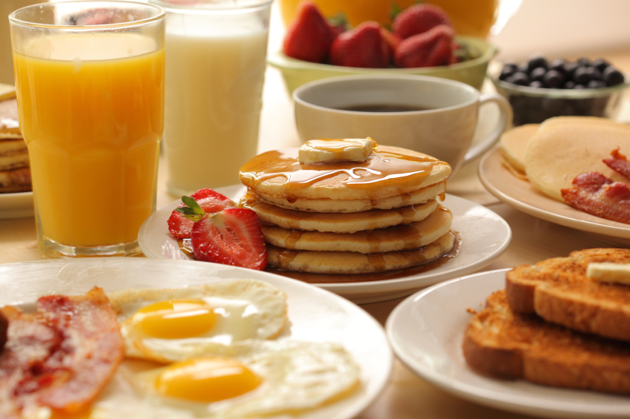

Vegetarian omelet with spinach, onions,
mushrooms, bell peppers, tomatoes
and feta cheese
Breakfast potatoes
Melon slices
Cottage cheese
| $13.95++

Deli Selections
Hoagies or Wraps | $13.95 ++
Deli Style Buffet | Lunch $20.95++ Dinner $23.95++
Minimum 20 people for buffet service
All pricings are based per person

We use Hormel Premium Sliced Meats

Hoagies:
(Includes lettuce, tomato & onion)
Turkey & Swiss
Turkey & Pepper Jack
Roast Beef & Cheddar
Ham & Swiss
Ham & Provolone
Club (turkey, ham and bacon)

Wraps:
(Includes lettuce & tomato)
California Club | diced chicken, bacon and shredded cheddar cheese with avocado salsa

Chicken Pesto | diced chicken tossed with pesto mayonnaise

Lunches include: Soda, tropical fruit cup, chips and fresh baked cookies

___________________________________________________

Deli Style Buffet
Garden salad with 2 choices of dressing
Mustard potato salad
Pasta salad
Assorted deli meats including:
Ham, turkey and roast beef
Deli rolls and breads with condiments on the side
Crudités of vegetables with herbed dip
Homemade cookies and brownies

Plated Served Meals
All pricings are based per person
All meals include: Premium roasted regular and decaf coffee, iced tea,
low fat milk, lemon ice water, fresh rolls & butter
~Chef’s Choice of Dessert~

Salad Choices: (Choice of one)
Garden salad with 2 choices of dressing
Spring mix salad with bleu cheese crumbles, walnuts and apples
Caesar salad with cut romaine, shredded parmesan and croutons
Caprese salad with sliced tomatoes, fresh mozzarella cheese, basil
and balsamic vinaigrette dressing
Strawberry salad with strawberries, cucumbers,
candied walnuts and feta cheese

OR

Soup Choices: (Choice of one)
Creamy tomato basil
Homemade chicken noodle or chicken and rice
Broccoli and cheddar
Vegetable beef
_______________________________________________

Starch Selections: (Choice of one)

Wilde rice
Rice pilaf
Risotto
Cous cous
Quinoa
Steamed white or brown rice
Au gratin potatoes

Redskin mashed potatoes
Twice baked potatoes
Baked potato with sour cream
& chives on the side
Seasoned baby potatoes
Baked sweet potato

~Plated Meals Continued~
~Plated Meals Continued~

Vegetable Selections: (Choice of one)
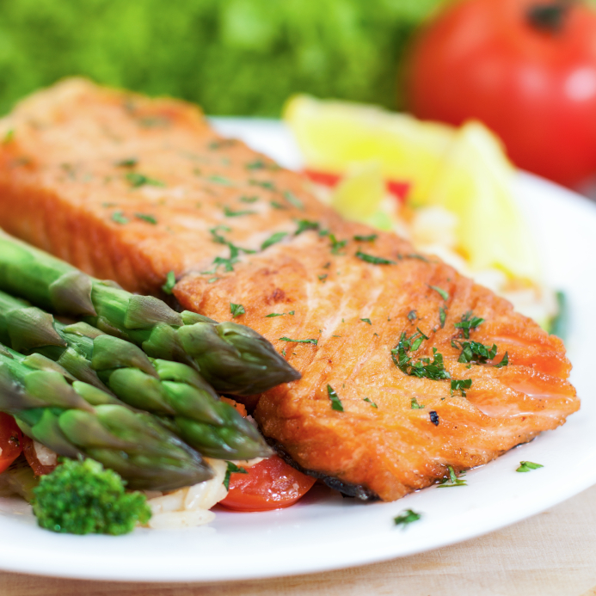

Steamed green beans with roasted red peppers
Sautéed zucchini and yellow squash
Buttered or grilled asparagus spears
Steamed vegetable medley
Roasted whole kernel corn
Broccoli

_______________________________________________

Entrée Choices: (Choice of one)

Homemade meatloaf with natural gravy
Cheese tortellini or ravioli with
pesto cream sauce
Traditional meat or vegetarian lasagna
Breaded pork chops with apple chutney
Roasted eggplant parmesan
Chicken marsala
Chicken cordon bleu
Grilled citrus chicken
Chicken piccata
Lunch | $20.95++
Sake marinated salmon
Citrus salmon
Southwestern tortilla crusted tilapia
Grilled tri tip with tomato relish
Roasted pork tenderloin w/ peppercorn demi glaze or raspberry chipotle sauce
Roasted prime rib of beef with
au jus and creamed horseradish
Filet mignon with shrimp scampi
Lunch | $24.95++
Dinner | $27.95++
Dinner | $23.95++

Buffet Meals:
Lunch | 2 Entrees $26.95++ per person, 3 Entrees $28.95++ per person
Dinner | 2 Entrees $28.95++ per person, 3 Entrees $30.95++ per person
Minimum 20 people for buffet service
All meals include: Premium roasted regular and decaf coffee, iced tea,
low fat milk, lemon ice water and fresh rolls & butter
~Chef’s Assorted Dessert Selection~

Salad Choices:
(Choice of two for up to 30 people, Choice of three for 30+ people)
Garden salad with 2 choices of dressings, Strawberry salad, Traditional Caesar, Creamy Cucumber salad with dill, Caprese salad, Mustard Potato salad, Greek Pasta salad, Fresh Fruit salad with seasonal berries, Ambrosia Salad, Marinated Mushroom and Artichoke salad, California Waldorf salad

_______________________________________________

Entrée Selections:
Homemade meatloaf with natural gravy
Cheese tortellini or ravioli with pesto cream sauce
Traditional meat or vegetarian lasagna
Breaded pork chops with apple chutney
Roasted eggplant parmesan
Chicken marsala
Chicken cordon bleu
Grilled citrus chicken
Chicken piccata
Lemon salmon
Grilled tri tip with tomato relish
Roasted pork tenderloin with peppercorn
demi glaze or rasberry chipotle sauce

~Buffet Meals Continued~
~Buffet Meals Continued~

Carver Station:
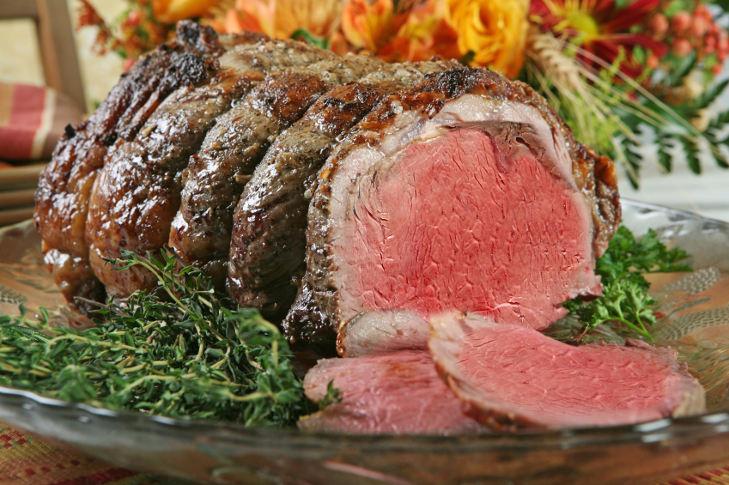
(Chef Carver fee of $75.00 will apply)
Roasted prime rib of beef with au jus and creamed horseradish
Honey glazed ham
Slow roasted turkey with
gravy and cranberry mayo

_______________________________________________

Starch Selections:
(Choice of One)

Wild rice
Rice pilaf
Risotto
Cous Cous
Quinoa
Steamed white or brown rice
Red skin mashed potatoes
Seasoned baby potatoes
Baked sweet potato
Homemade stuffing
Au Gratin potatoes
Twice baked potatoes

Baked potato with
sour cream & chives on the side

_______________________________________________

Vegetable Selections:
(Choice of One)
Steamed green beans with roasted red pepper
Sautéed zucchini and yellow squash
Buttered or grilled asparagus spears
Steamed vegetable medley
Roasted whole kernel corn
Broccoli

Themed Menus
Lunch | $23.95++ per person
Dinner | $26.95++ per person
Minimum 20 people for buffet service
All meals include: Premium roasted regular and decaf coffee, iced tea, low fat milk and lemon ice water

Western Buffet
Garden salad with sliced bell pepper,
corn kernels and black beans
Coleslaw
Mustard potato salad
Sautéed corn
Ranch style beans
Choice of 2:
Grilled chicken
Pulled pork
Ribs
Biscuits and cornbread with
butter on the side
Cherry and apple pie

Oriental Buffet
Baby spinach salad with mushrooms, sprouts, radishes, water chestnuts
and jicama with ginger sesame dressing
Crudités of vegetables with dip
Beef and broccoli
Teriyaki chicken and vegetable stir fry
Egg rolls
Fried rice and brown rice
Fortune cookies

____________________________________________________________

Italian Buffet
Traditional caeser salad with shredded parmesan, croutons and
dressing on the side
Caprese salad with sliced tomatoes,
mozzarella cheese, basil and
balsamic vinaigrette dressing
Pasta salad
Choice of 2:
Chicken parmesan over spaghetti noodles
Meat or vegetarian lasagna
Baked penne pasta
Meatballs in red or alfredo sauce
Garlic bread
Cannolis and tiramisu
Mexican Buffet
Garden salad with diced bell peppers,
onions and tortilla strips with
chipotle ranch dressing
Fresh fruit salad with mangoes
Mexican black bean and corn salad
Spanish rice and refried beans
Flour tortillas
Guacamole, sour cream and cheese
Homemade salsa and tortilla chips
Choice of 2:
Cheese enchiladas
Chicken or beef fajitas
Chile relleno
Chicken or beef street tacos
Tres Leches Cake

