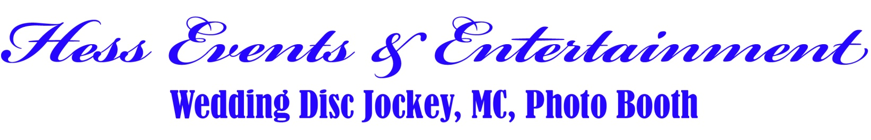
What Can We Do For Your Wedding?  MC Services  Announcements for Grand Entrance, Toast, Cake Cutting, First Dance, Parents Dance, Bouquet Toss, Garter Toss, Etc...  Professional Sound & Lighting  For both Ceremony and Reception  Easy On-Line Planning Worksheets  We will set you up with our on-line state of the art wedding planning website where you can easily select music and plan your special day.  Pre Event Consultations  Prior to the event we will sit down with you and do all the detailed planning so your event can run flawlessly.  Professional DJ  With over 15 years of experience specializing in wedding entertainment you can be certain you’ve found the perfect match of elegance and fun. |  | 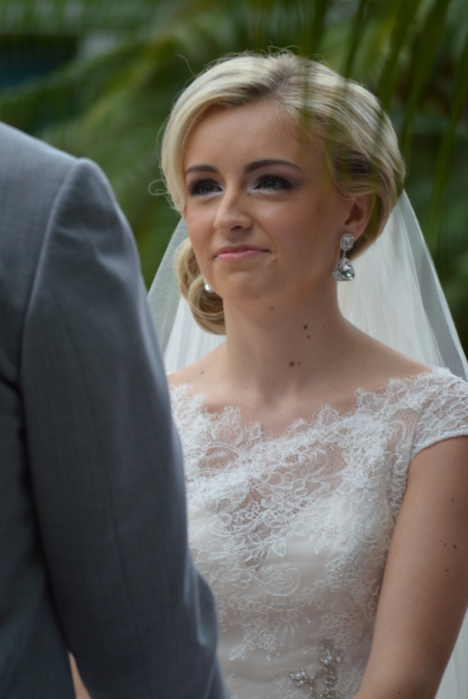
DJ PACKAGE PRICE!
Starting at $795 for the first 4 Hours / $130 Each Additional Hour
Includes Dance Lighting, Wireless Microphone for toasts, Professional Sound System,
Outdoor Ceremony only $300.00 and includes separate sound system, Wireless Microphone,
Musical backdrop for Your Ceremony including Guests arrival, Processionals, and Recessional.
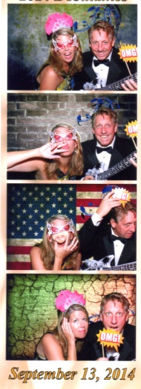 | Photo Booth Package with DJ  $350 For first 2 Hours, $100 Each Additional Hour.  Unlimited B/W or Color pictures prints on site  Choose from 2 x 6 or 4 x 6 prints  Numerous outrageous and fun props  Custom message on all prints  On sight attendant  Flash Drive of all photos taken  Additional Items  $75.00 Leather Embroidered Photo Album  $75.00 Remote monitor for slideshow of photos  $100.00 Green Screen Fun  *** Dates Are Limited - Book Your Event Today *** |  | 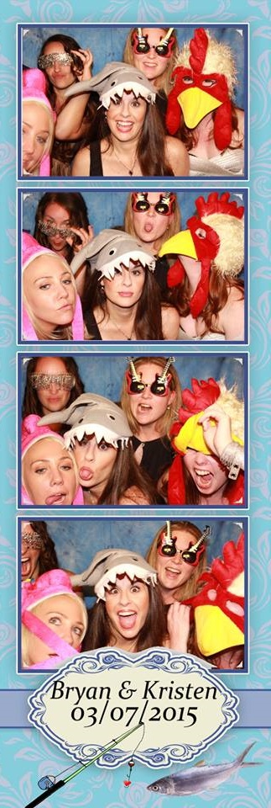
Hess Events & Entertainment
Phone: 941-244-3456
Web: www.hessevents.com - Facebook: www.facebook.com/hesseventssarasota

