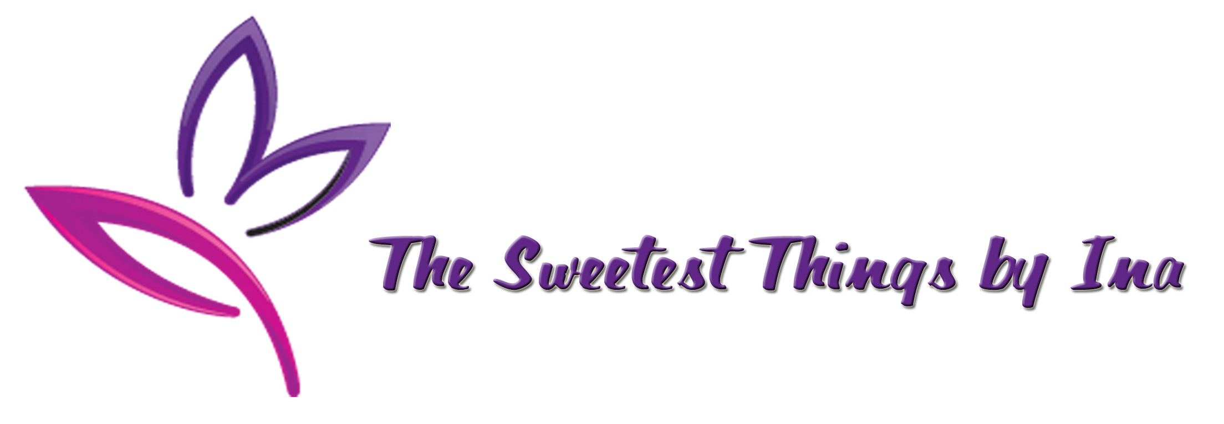
“We don’t just create memories…we make them Sweet”
______________________________________________________________________________________

SERVICES

Plans and Organizes Events Such As:

Birthday, Wedding, Anniversary, Quinceanera, Engagement/ Wedding Proposal, Bridal/ Wedding Shower, Baby Shower, Christening/ Baptismal, Reunions, Bar/ Bat Mitzvah, Seminars, Fundraising Event, Company Meeting, Company Party, Thanksgiving, House Warming, Job Promotion, Graduation, Retirement, Business Grand Opening, Product Launch, Going Away Party, Halloween Party, Christmas Party, Karaoke Party, Zumba Party, Make Over Party, Themed Party, etc.

Provides for your Party Needs:

Host/ Emcee, Organizer/ Planner, DJ/ Lights and Sounds, Uplighting, Venue, Photographer, Videographer, Wedding Officiant, Invitation, Souvenir/ Give Away, Tables, Chairs, Linen, Chair Cover and Bows, Canopy, Decoration, Flowers, Cake, Hair and Make Up Artist, Couturier, Engagement/ Wedding Rings, Media Wall, Photobooth, Banner, Life-size Stand-Ins, Balloons, Dance Floor, Stage ,Overhead Projectors, Projector Screen, Candy Buffet, Sweet Station, Jumpers, Party Bus, Limousine, Face Painting, Magician, Balloon Twister, Caricaturist, Popcorn Machine, Shaved Ice Machine, Cotton Candy Machine, Hotdog Machine, Clowns, Heaters, Gazebos, Chafing Dish, etc.
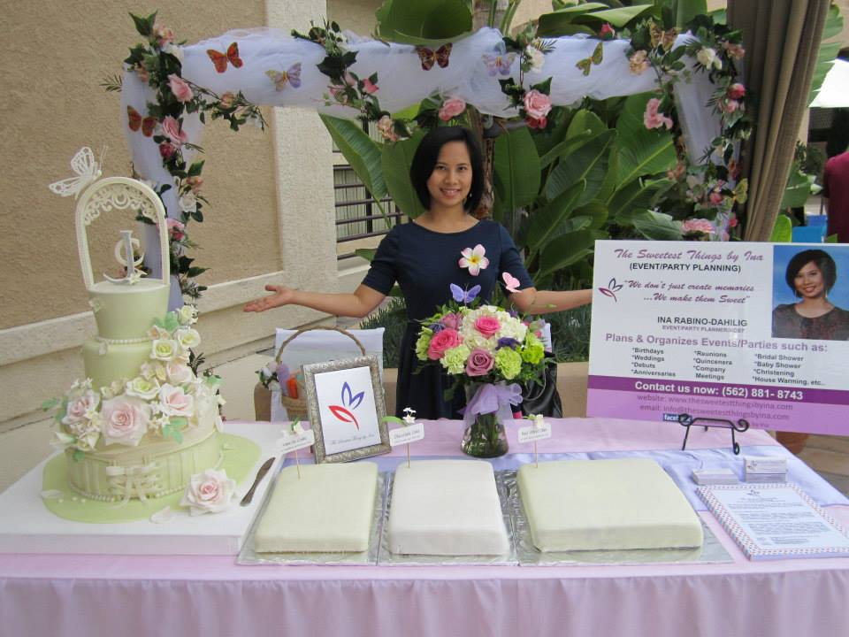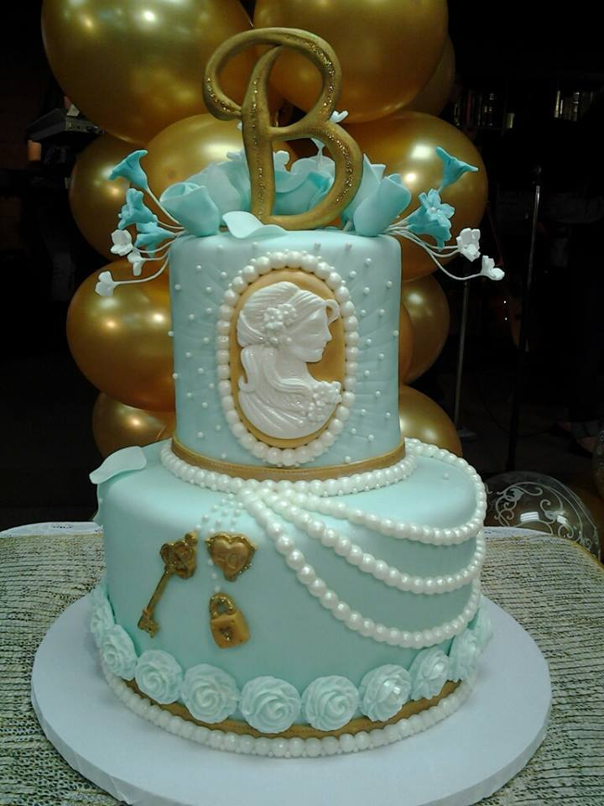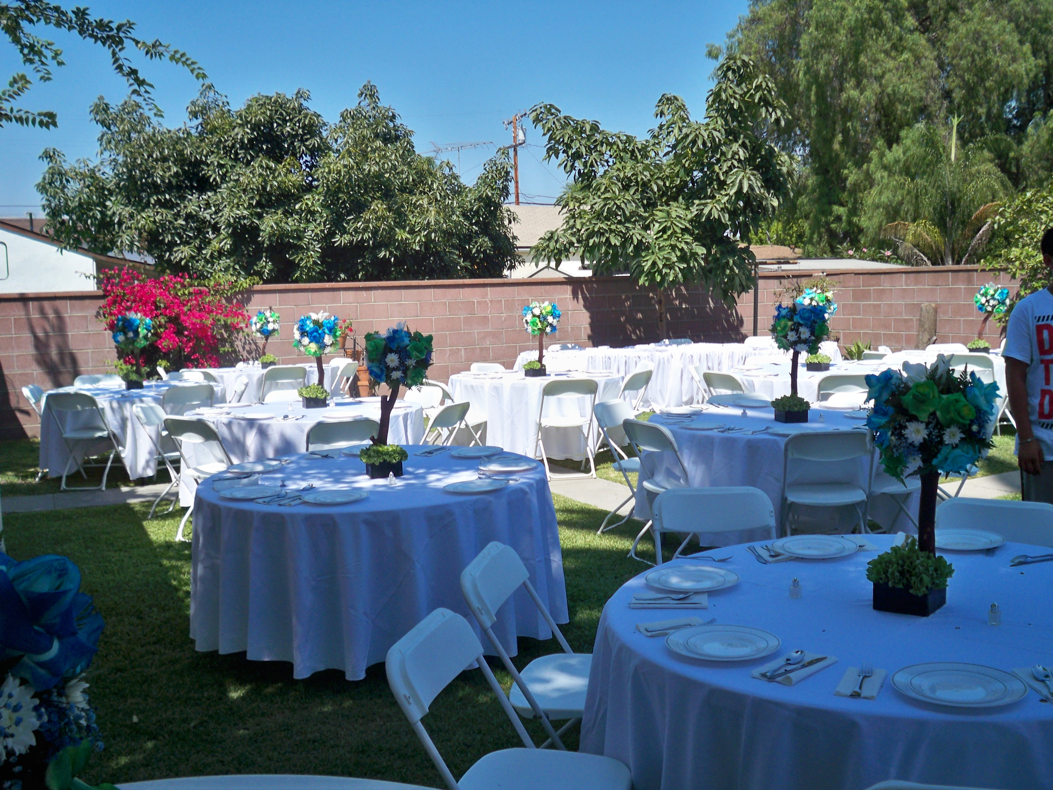
____________________________________________________________________________________
21834 Belshire Ave., Unit 6, Hawaiian Gardens, CA 90716
www.thesweetestthingsbyina.com
thesweetestthingsbyina@yahoo.com
Telephone # 562-881-8743

